**Lexar® JumpDrive® M900 USB 3.2 Gen 1 Flash Drive**

256GB

128GB

64GB

[Where to buy](https://americas.lexar.com/product/lexar-jumpdrive-m900-usb-3-2-flash-drive/)

**Key Features:**

Up to 400MB/s read

* High-Speed Performance
* With Key Ring
* Compatible with PC and Mac Systems
* 256-bit AES

**Key Features:**

Up to 400MB/s read

* High-Speed Performance
* With Key Ring
* Compatible with PC and Mac Systems
* 256-bit AES

**Key Features:**

Up to 400MB/s read

* High-Speed Performance
* With Key Ring
* Compatible with PC and Mac Systems
* 256-bit AES

[Features](https://americas.lexar.com/product/lexar-jumpdrive-m900-usb-3-2-flash-drive/#feature-section)[Specifications](https://americas.lexar.com/product/lexar-jumpdrive-m900-usb-3-2-flash-drive/#specifications)[Part Numbers](https://americas.lexar.com/product/lexar-jumpdrive-m900-usb-3-2-flash-drive/#product-numbers)[Related products](https://americas.lexar.com/product/lexar-jumpdrive-m900-usb-3-2-flash-drive/#related-products)

**Features**

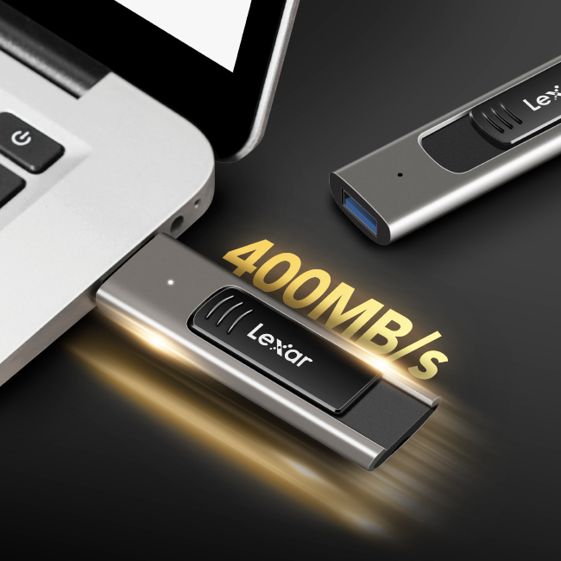

**Move your files with style and speed**

Store your data with style and speed with the Lexar® JumpDrive® M900 USB 3.2 Flash Drive. With fast USB 3.2 transfer speeds up to 400MB/s¹, save time and transfer your files in a flash. And with a durable metal design, this USB is as durable as it is classic.

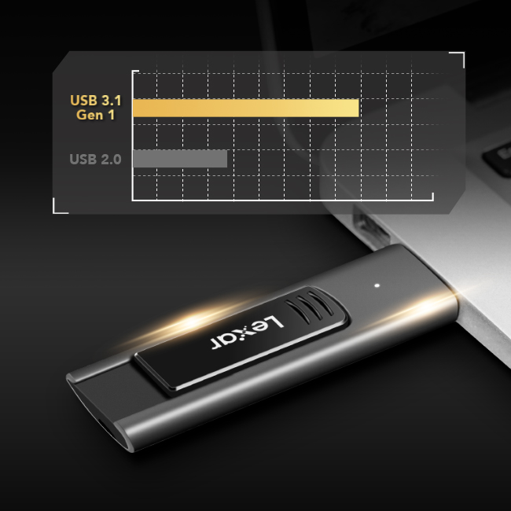

**Read speeds up to 400MB/s1**

With USB 3.2 performance and read speeds up to 400MB/s1, save time and transfer your files in a flash.

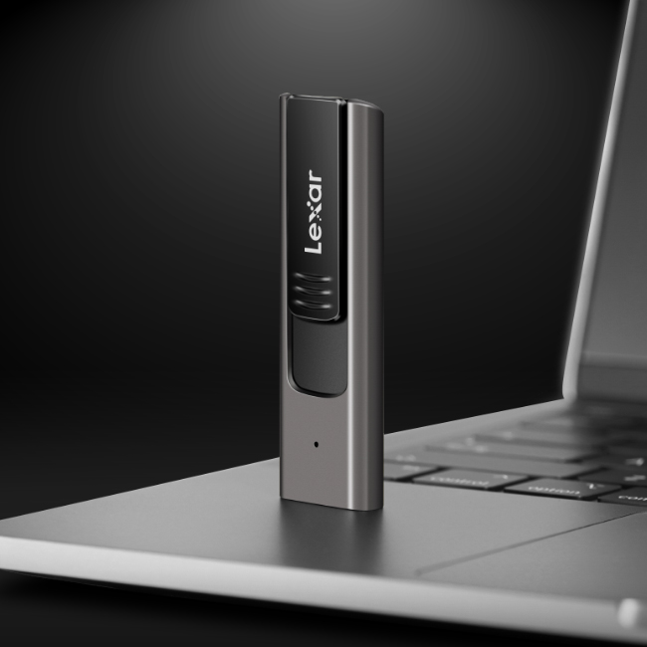

**Rugged and tough**

With a durable metal design, the JumpDrive® M900 USB 3.2 Flash Drive is designed to keep your data safe from the elements, between work and home.

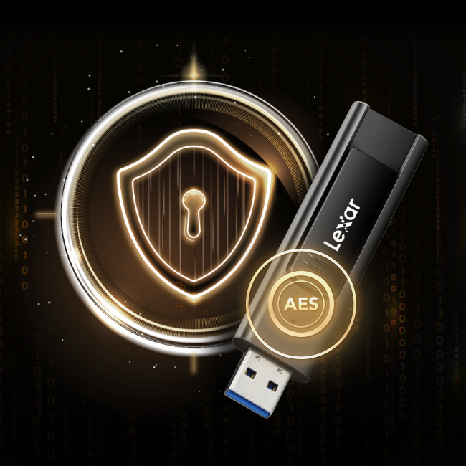

**Secure essential files with Lexar DataShield**

The JumpDrive® M900 USB 3.2 Flash Drive is secured by Lexar DataShield, the advanced security solution with 256-bit AES encryption² to keep your essential files secure from corruption, loss, and deletion.

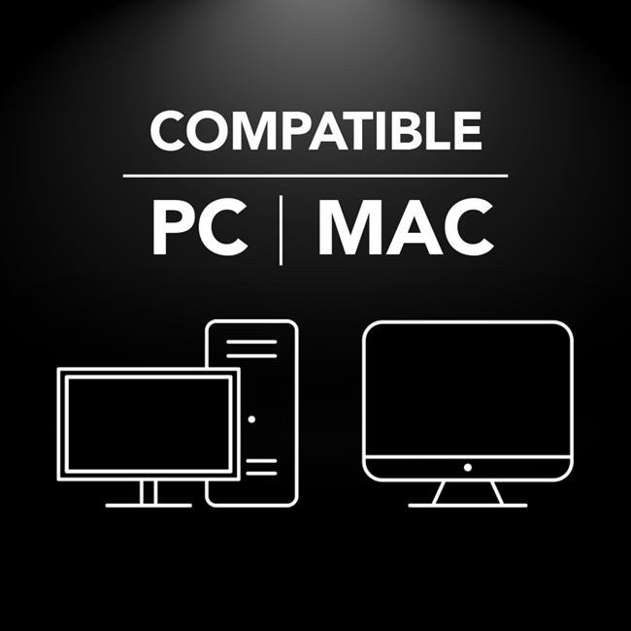

**Compatible with PC and Mac® systems**

Compatible with both PC and Mac® systems, the JumpDrive® M900 USB 3.2 Flash Drive allows you to easily store a large number of photos, videos, and documents.



**Rigorously Tested**

All Lexar products undergo extensive testing in the Lexar Quality Labs, facilities with thousands of different cameras and digital devices to ensure performance, quality, compatibility, and reliability.

**Specifications**

* Capacity

256GB | 128GB | 64GB

* Interface

USB 3.2 Gen 1

* Performance

64GB-Up to 300MB/s¹  
128GB-256GB-Up to 400MB/s¹

* Operating Temperature

0°C~50°C (32℉ to 122℉)

* Storage Temperature

-10°C~70°C (14℉ to 158℉)

* Dimension (L x W x H)

71.51mm x 21.93mm x 10.98mm / 2.81” x 0.86” x 0.43”

* Weight

28.1 g / 0.06 lbs

* Warranty

5-year limited warranty